1. Agenda:
   1. Showcasing the consumption of msg when we have three consumers in the same group.
2. All the 3 instances are reading from the same topic and at the same time they are part of the same group then one msg must be consumed by only one of them.
3. 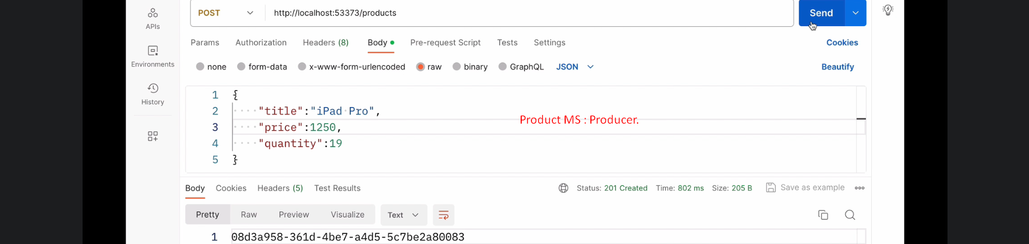
4.   
     
     
   